Closed Curved Shapes
# Source: AI Source: Provided by: [Data Path: Persons Table -> ID Column: 1, Name_En Column: Motasem Essam] -> From: [ChatGPT] on [7/25/2026]
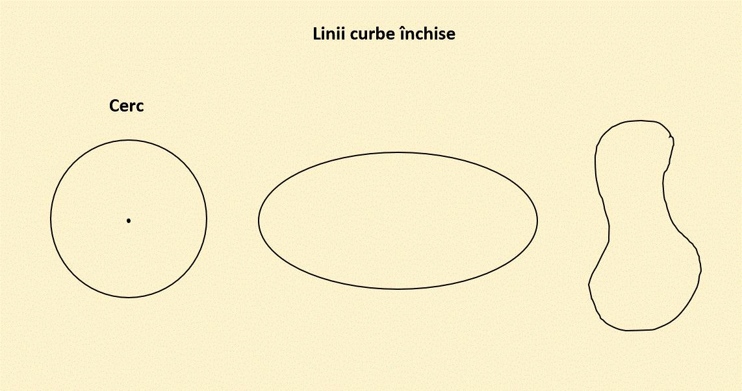
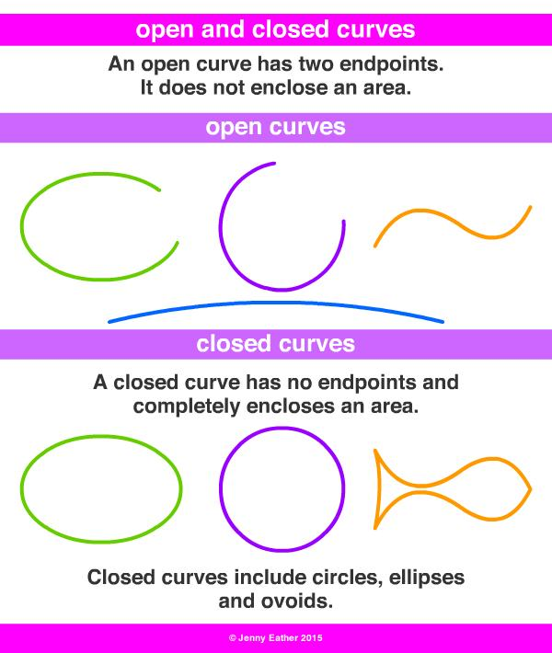
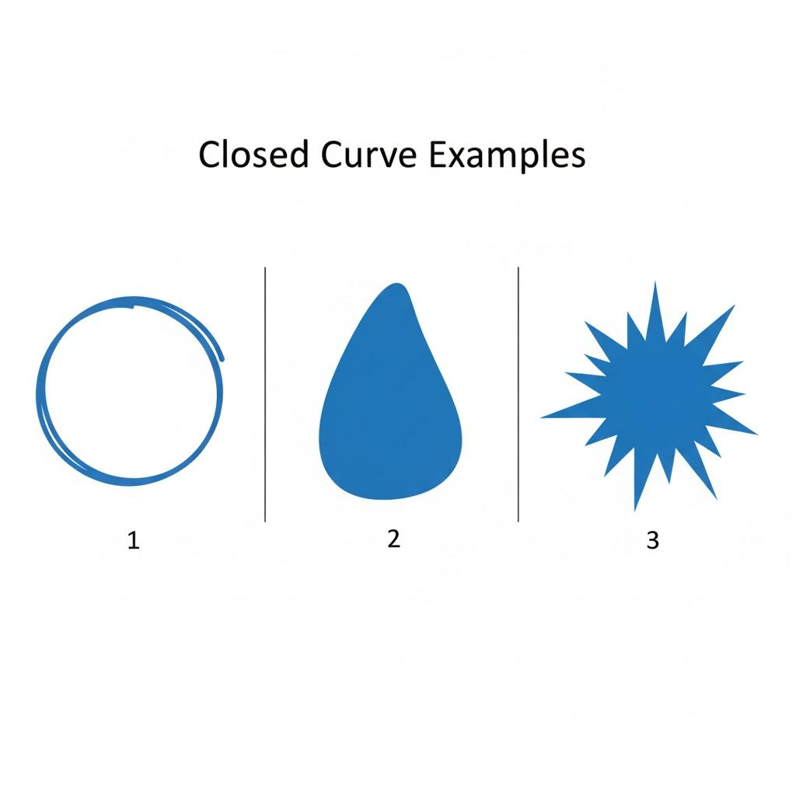

Definition
# Source: AI Source: Provided by: [Data Path: Persons Table -> ID Column: 1, Name_En Column: Motasem Essam] -> From: [ChatGPT] on [7/25/2026]
A Closed Curved Shape is a closed plane shape whose boundary contains curved lines and returns to its starting point, enclosing a bounded region.
In simple terms:
It is a closed shape made primarily or entirely from curved boundaries.
$$\boxed{\text{Closed Curved Shape}=\text{Closed}+\text{Curved Boundary}+\text{Enclosed Region}}$$

Characteristics
# Source: AI Source: Provided by: [Data Path: Persons Table -> ID Column: 1, Name_En Column: Motasem Essam] -> From: [ChatGPT] on [7/25/2026]
A closed curved shape typically:
- Is closed.
- Has no endpoints exposed to the exterior.
- Contains a continuous curved boundary.
- Returns to its starting point.
- Encloses a bounded interior region.
- Has an exterior region.
- Does not consist entirely of straight line segments.
- May have regular or irregular curvature.
- May be symmetric or asymmetric.

Types of Closed Curved Shapes

1. Circular Closed Shapes
# Source: AI Source: Provided by: [Data Path: Persons Table -> ID Column: 1, Name_En Column: Motasem Essam] -> From: [ChatGPT] on [7/25/2026]
A circular closed shape has a boundary in which every point is the same distance from a fixed center.
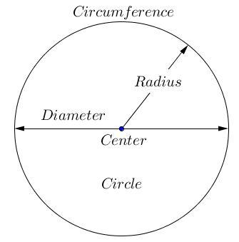
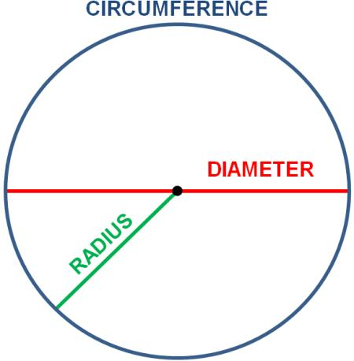
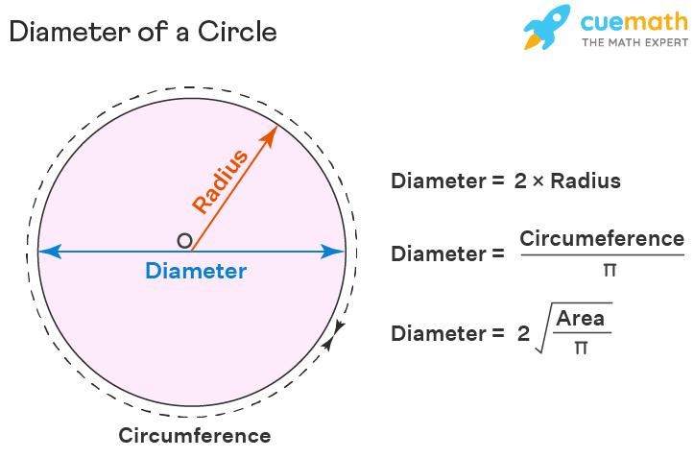
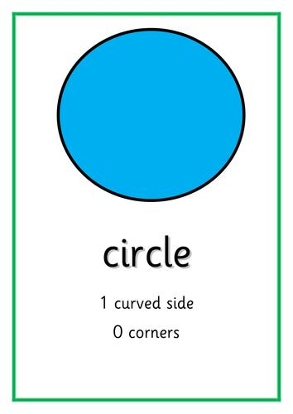
$$\boxed{{\left(x-h\right)}^{2}+{\left(y-k\right)}^{2}=r^{2}}$$
Examples:
- Circle
- Concentric circles
- Circular rings

2. Elliptical Closed Shapes
# Source: AI Source: Provided by: [Data Path: Persons Table -> ID Column: 1, Name_En Column: Motasem Essam] -> From: [ChatGPT] on [7/25/2026]
An ellipse is a closed curved shape with two principal axes and two foci.
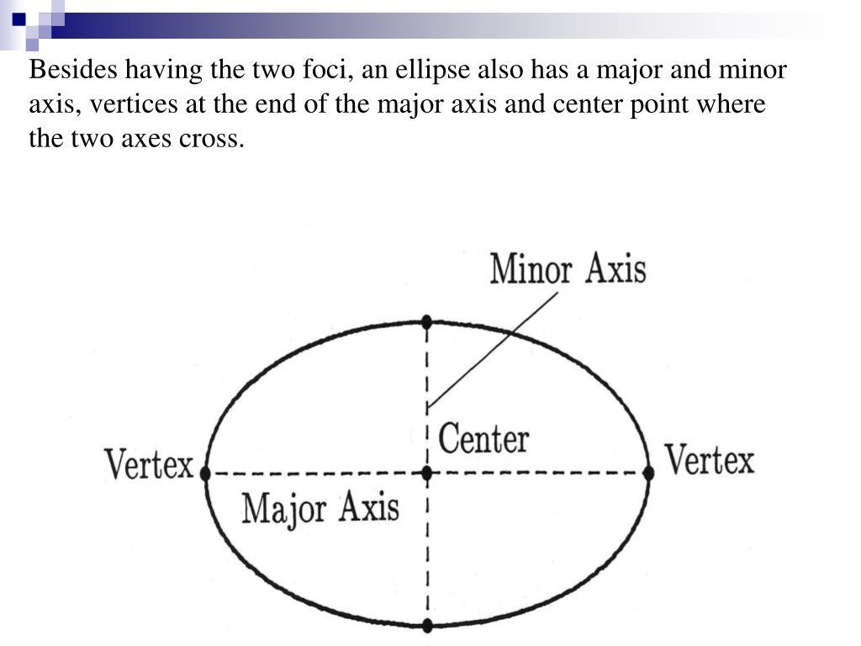
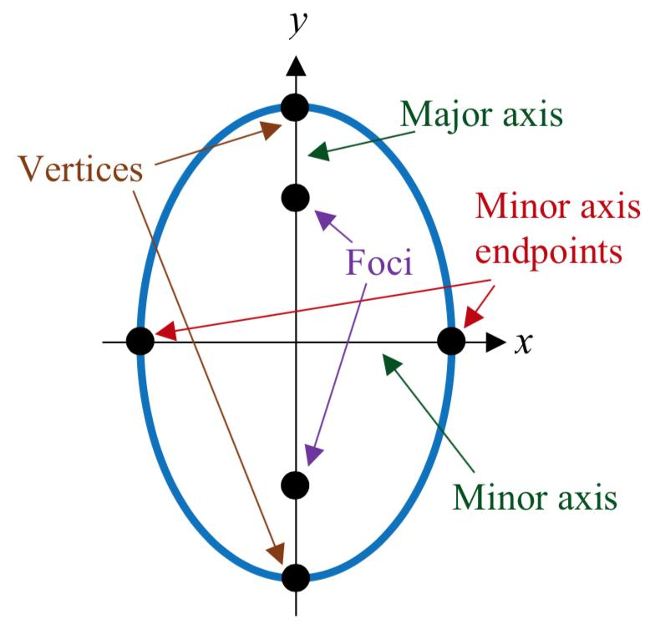
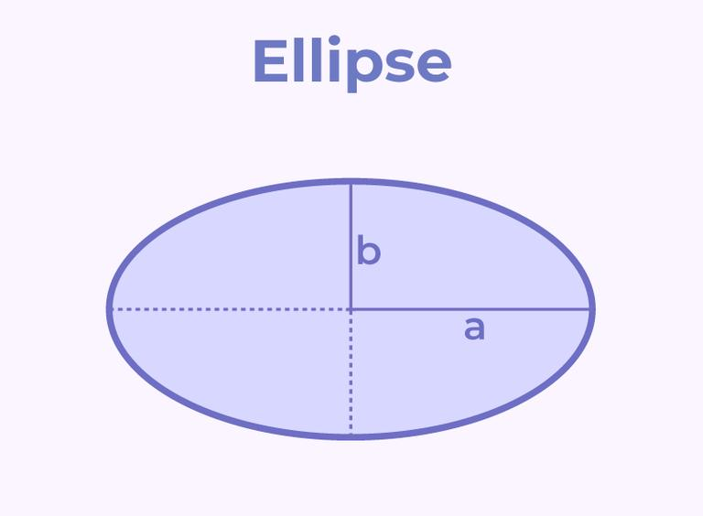
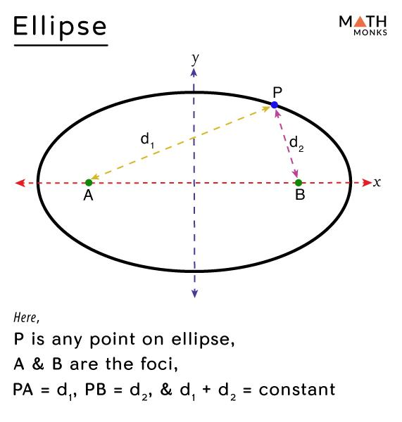
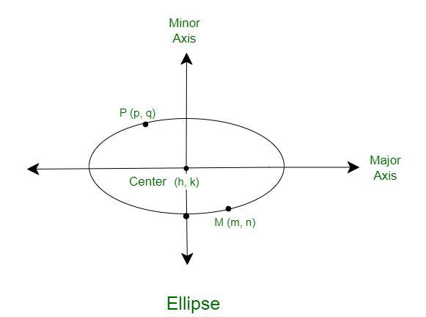
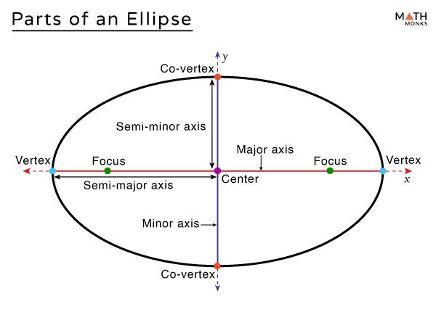
Its standard equation is:
$$\boxed{\frac{{\left(x-h\right)}^{2}}{a^{2}}+\frac{{\left(y-k\right)}^{2}}{b^{2}}=1}$$

3. Oval Closed Shapes
# Source: AI Source: Provided by: [Data Path: Persons Table -> ID Column: 1, Name_En Column: Motasem Essam] -> From: [ChatGPT] on [7/25/2026]
An oval is a general rounded closed shape resembling an ellipse but not necessarily satisfying the exact mathematical definition of an ellipse.
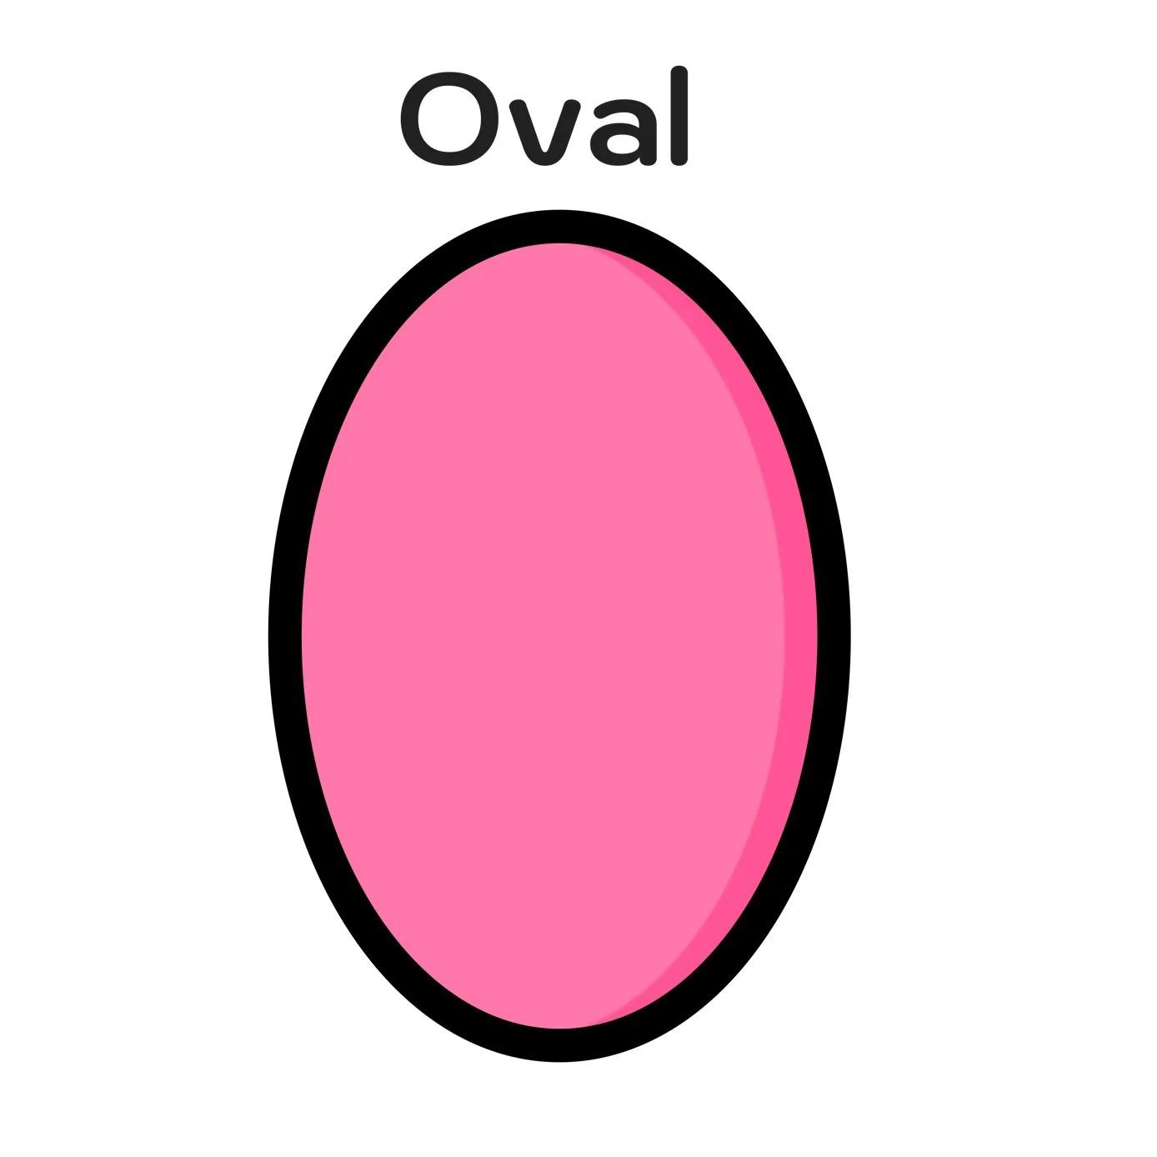
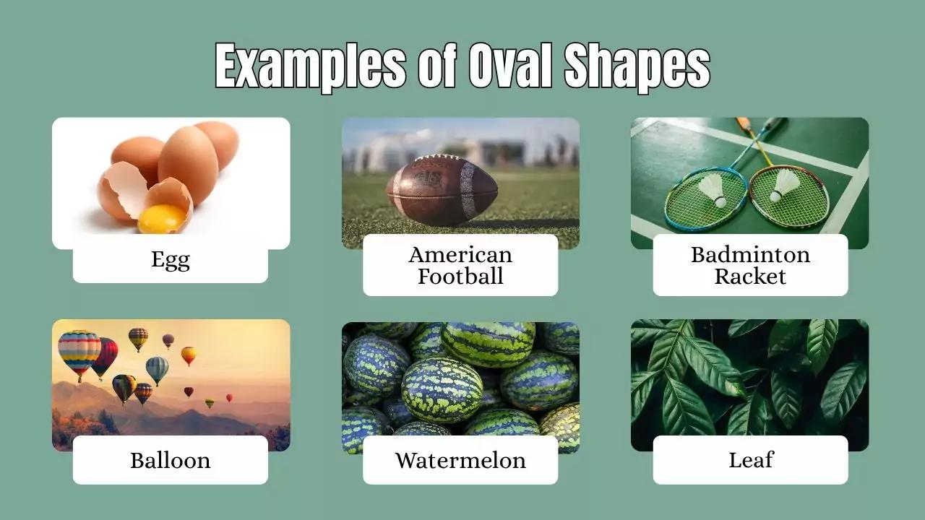
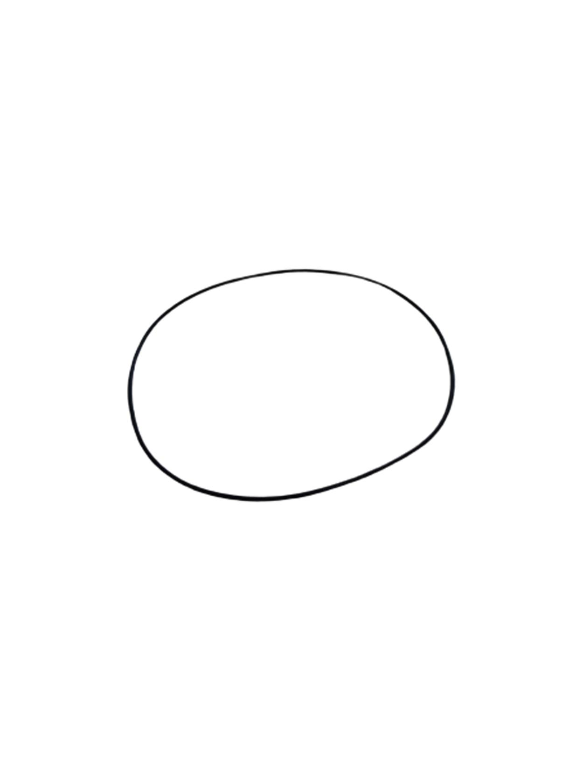
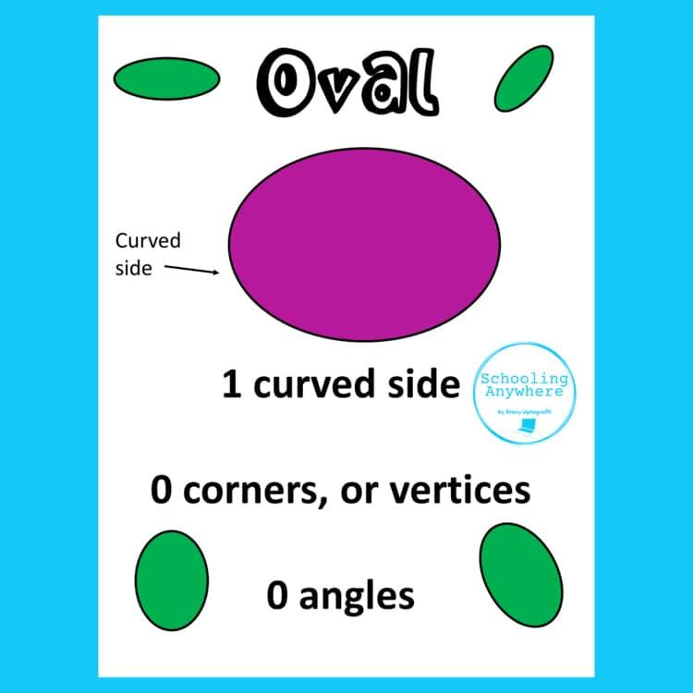
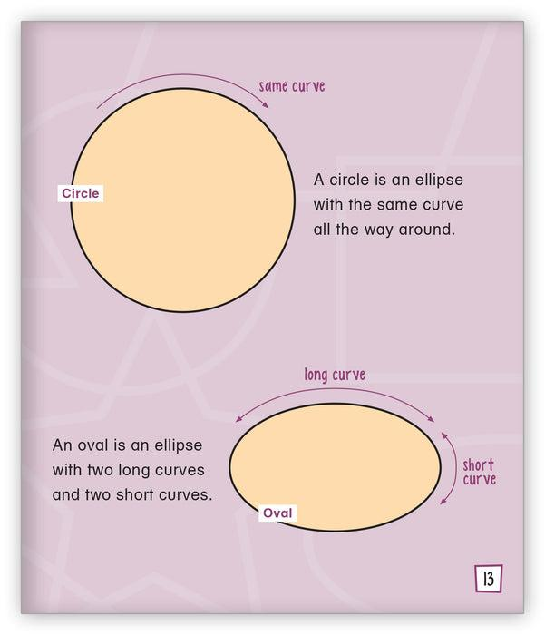
An oval can therefore be treated as a broader visual category than an ellipse.

4. Organic Closed Curved Shapes
# Source: AI Source: Provided by: [Data Path: Persons Table -> ID Column: 1, Name_En Column: Motasem Essam] -> From: [ChatGPT] on [7/25/2026]
These are closed curves with smooth, natural-looking, irregular forms.
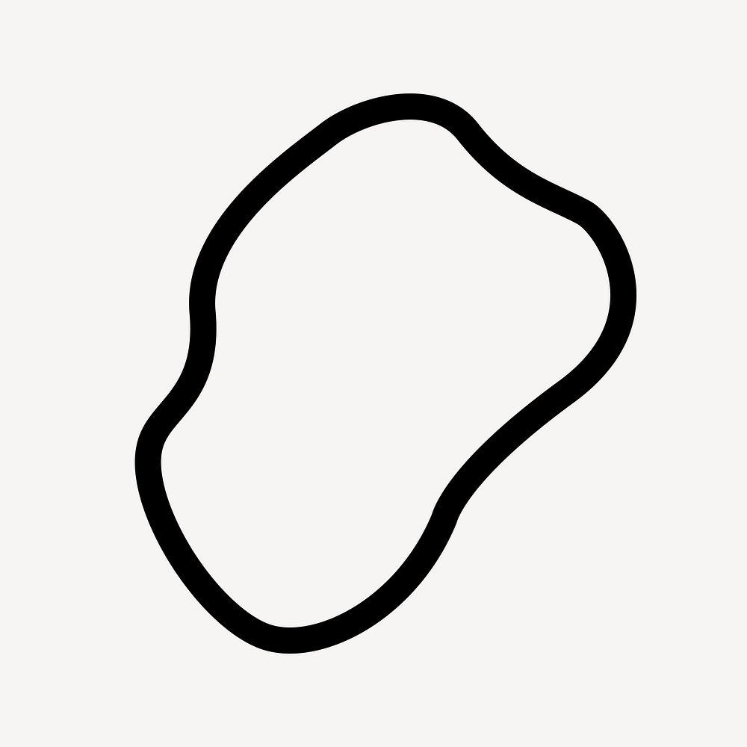
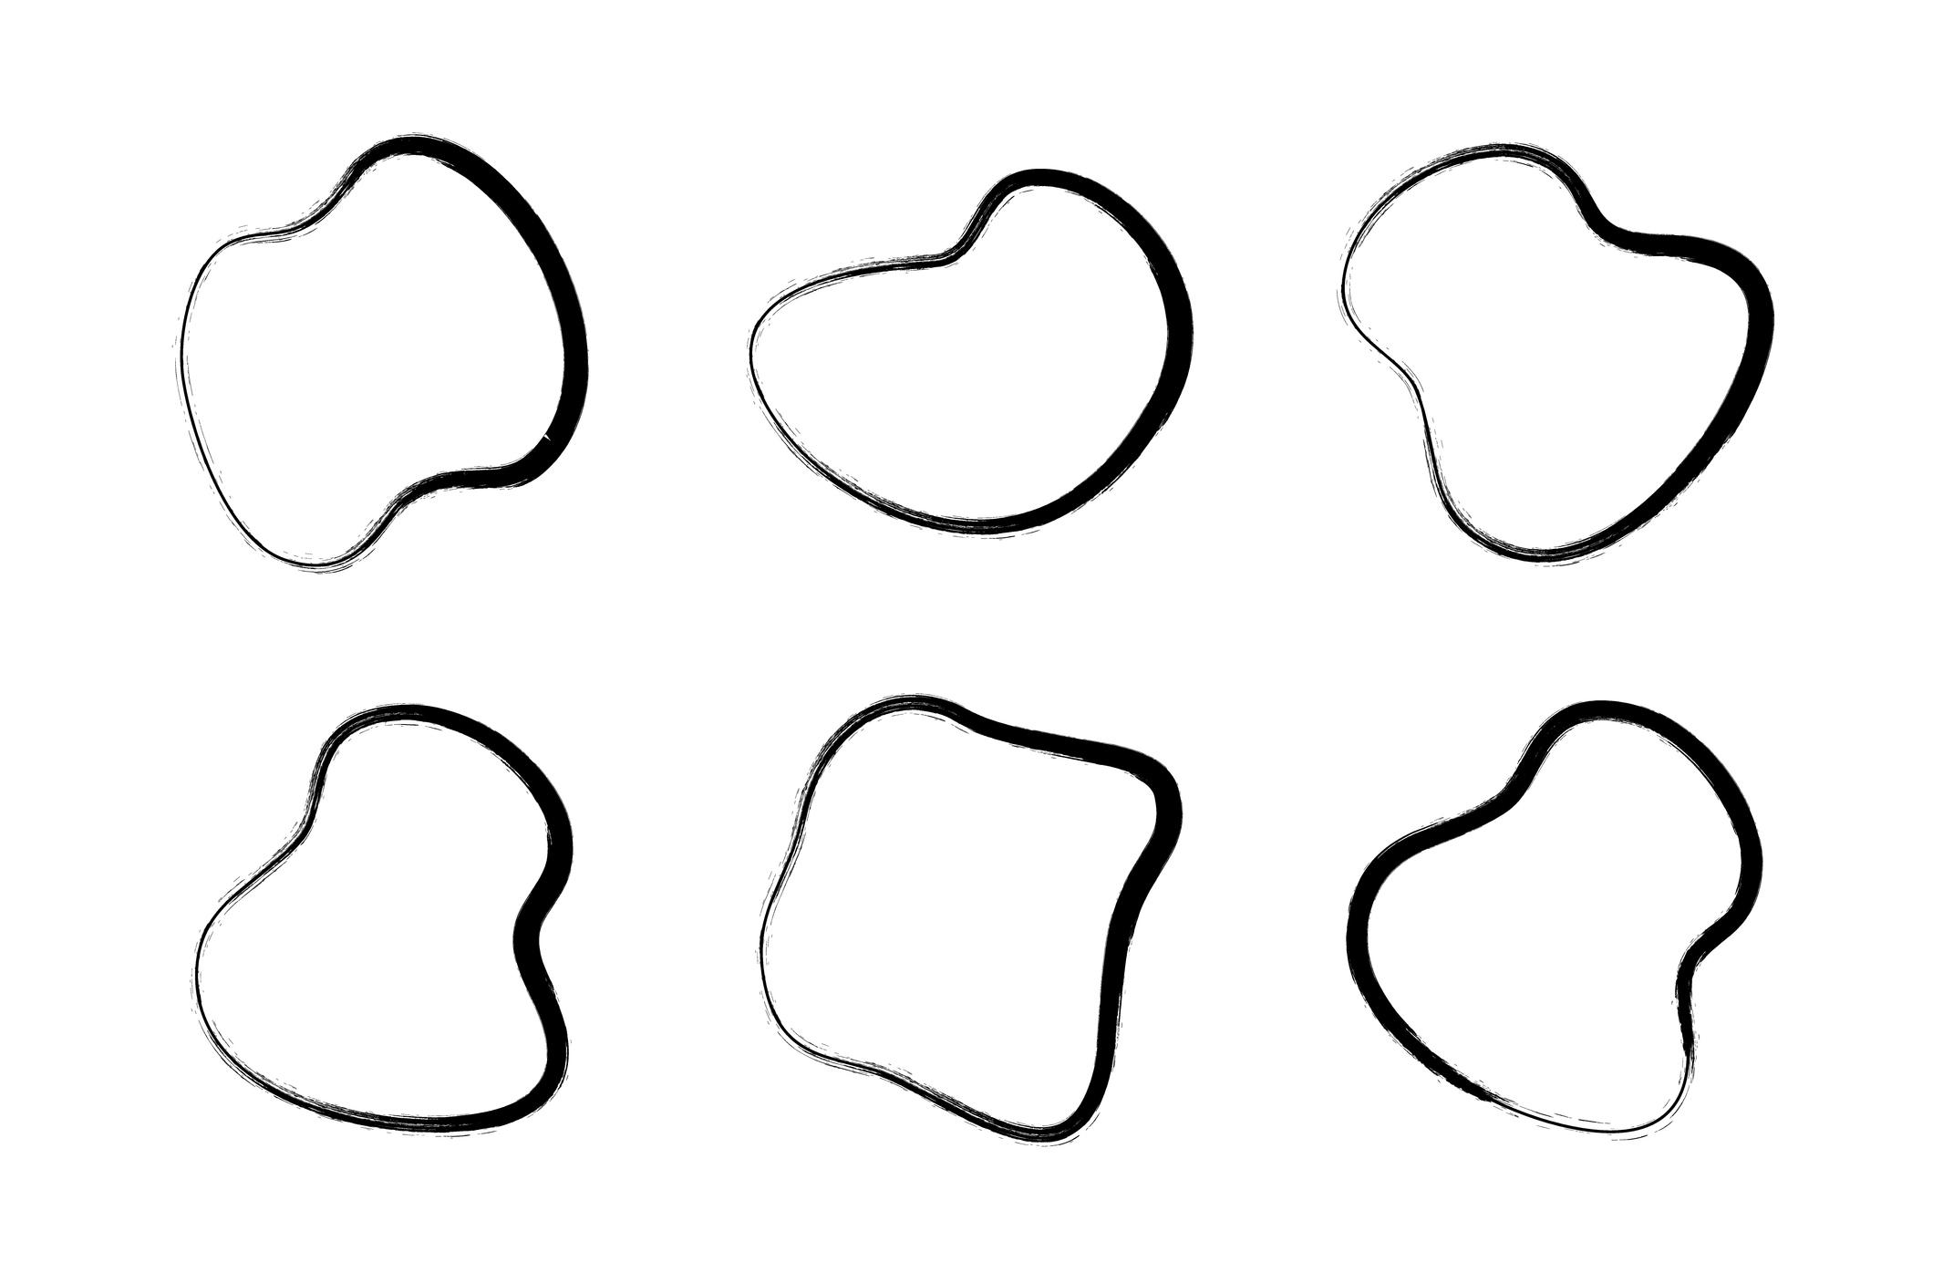
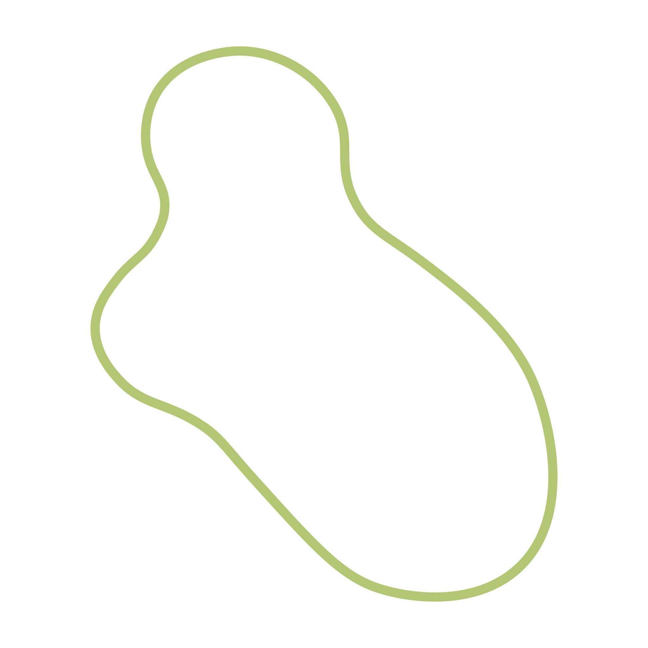
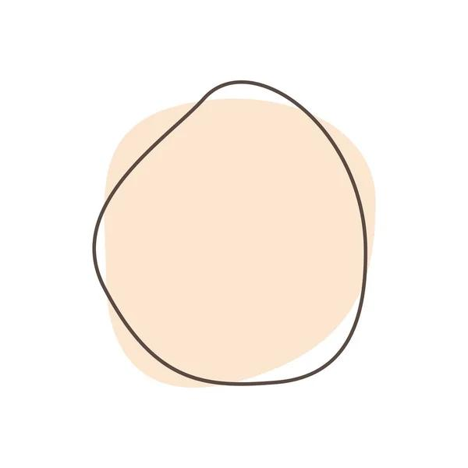
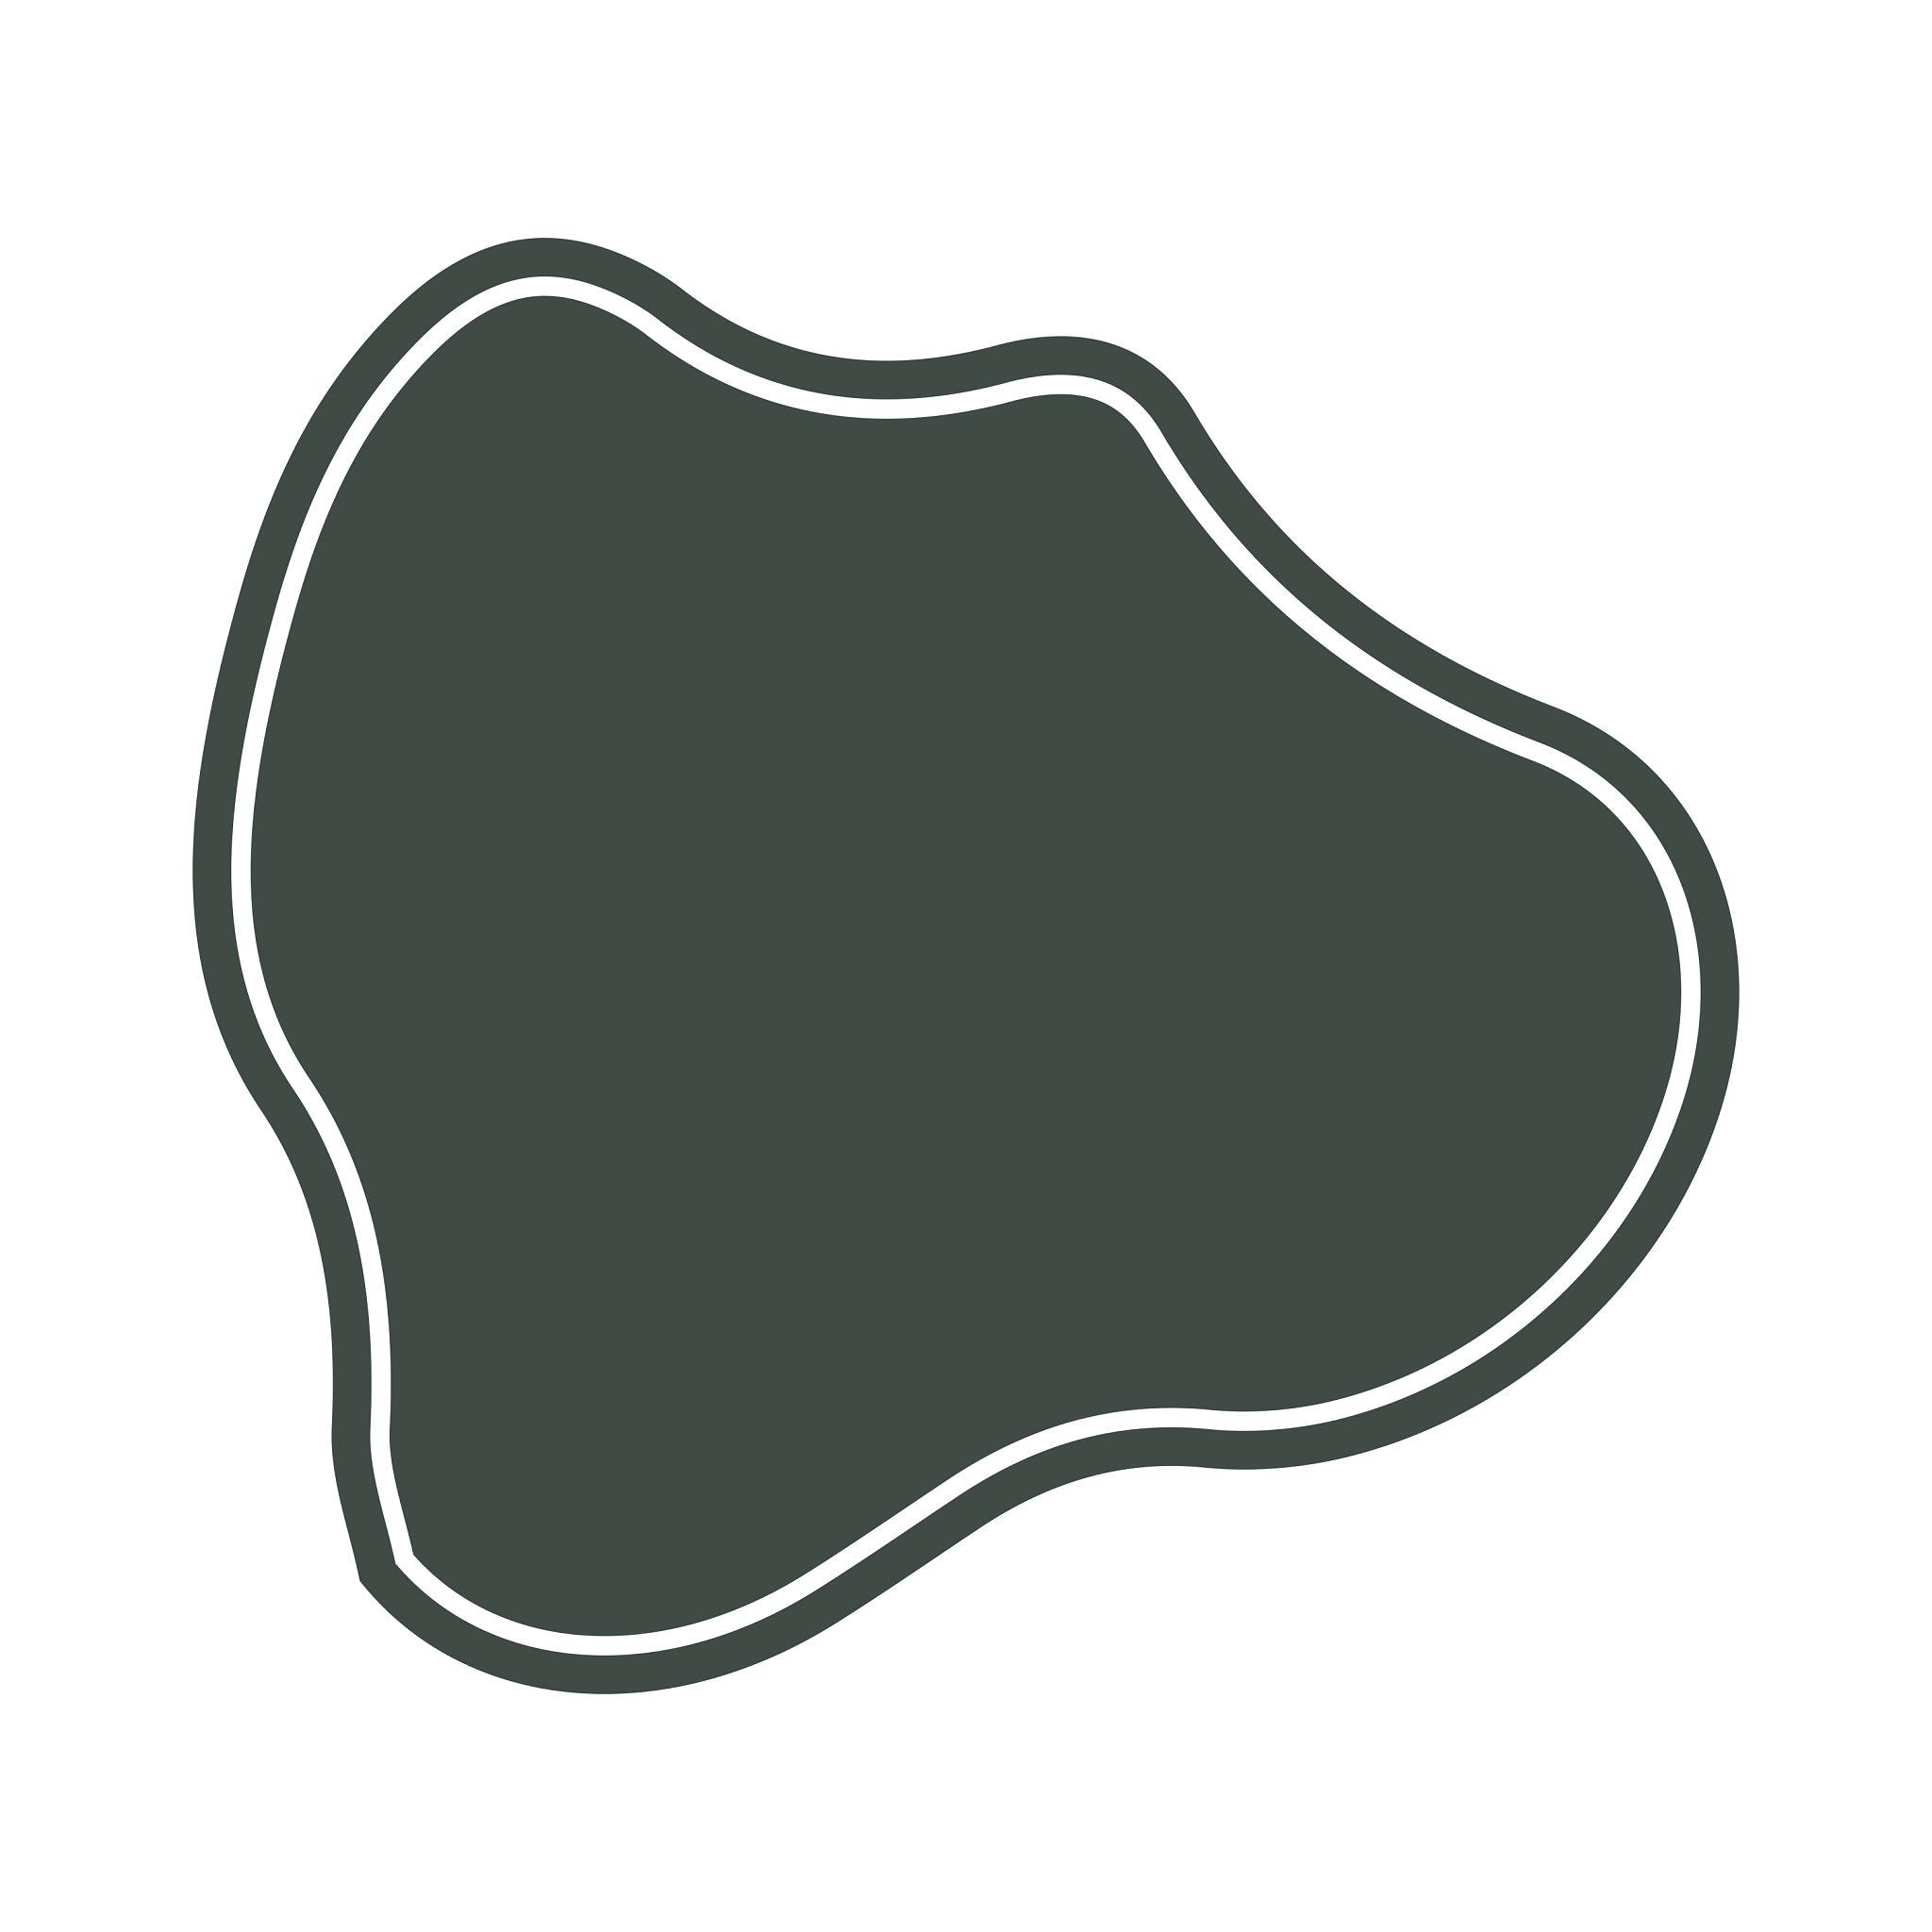
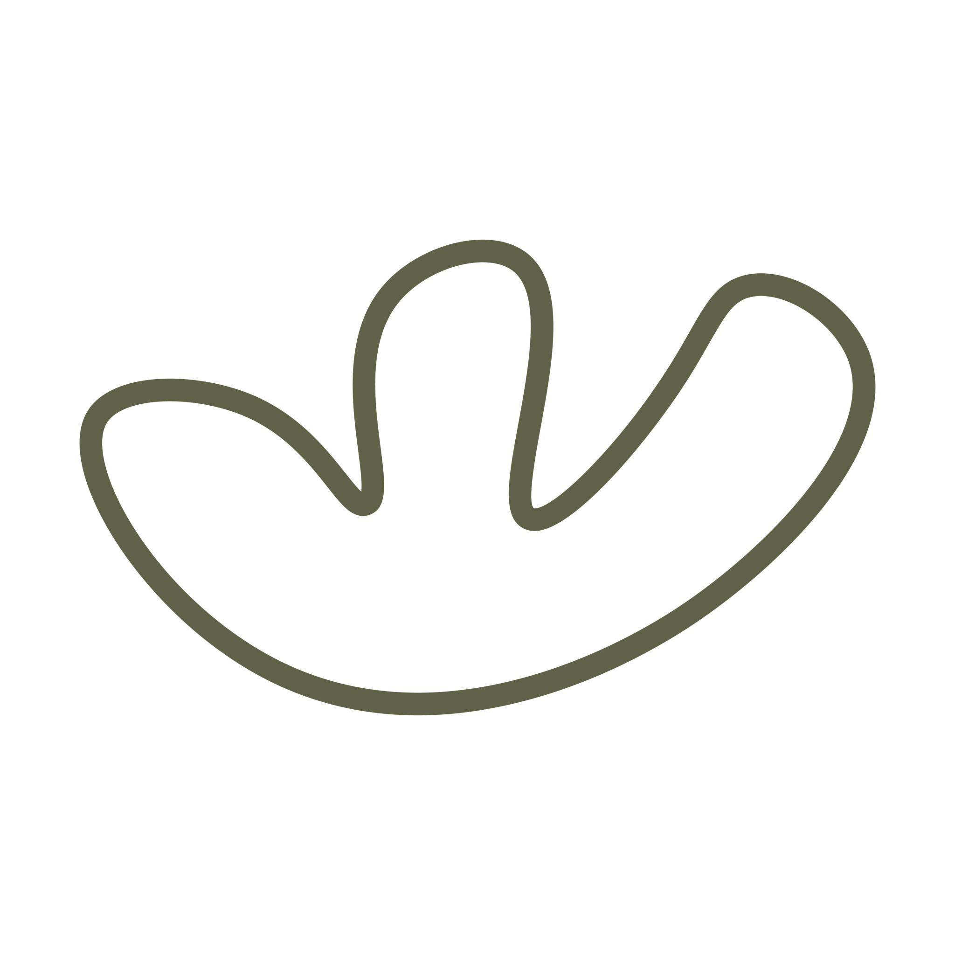
Examples may resemble:
- Leaves
- Pebbles
- Clouds
- Cells
- Natural body outlines
They do not necessarily follow a standard mathematical curve.

5. Freeform Closed Curved Shapes
# Source: AI Source: Provided by: [Data Path: Persons Table -> ID Column: 1, Name_En Column: Motasem Essam] -> From: [ChatGPT] on [7/25/2026]
These are artificially designed closed curves whose curvature is freely controlled.
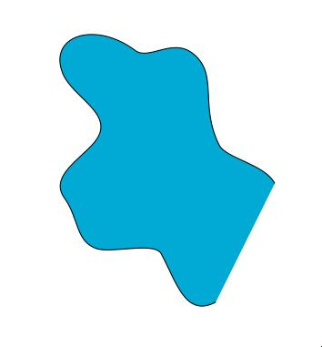
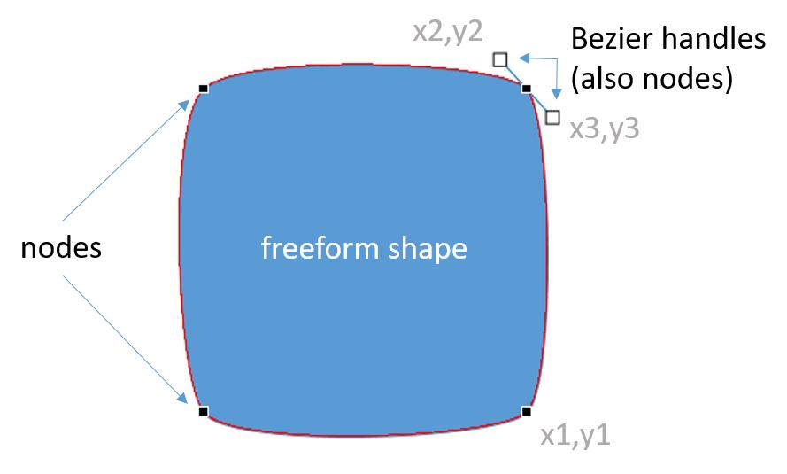
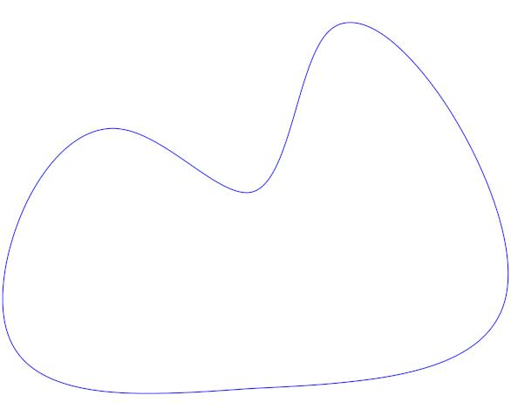
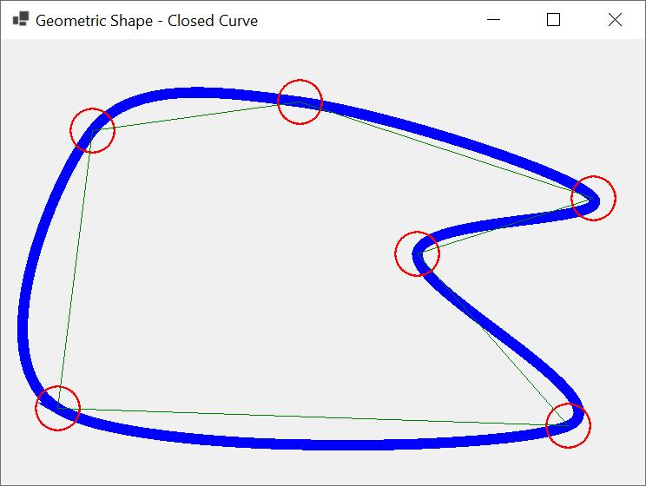
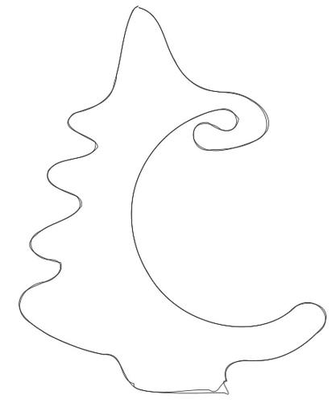
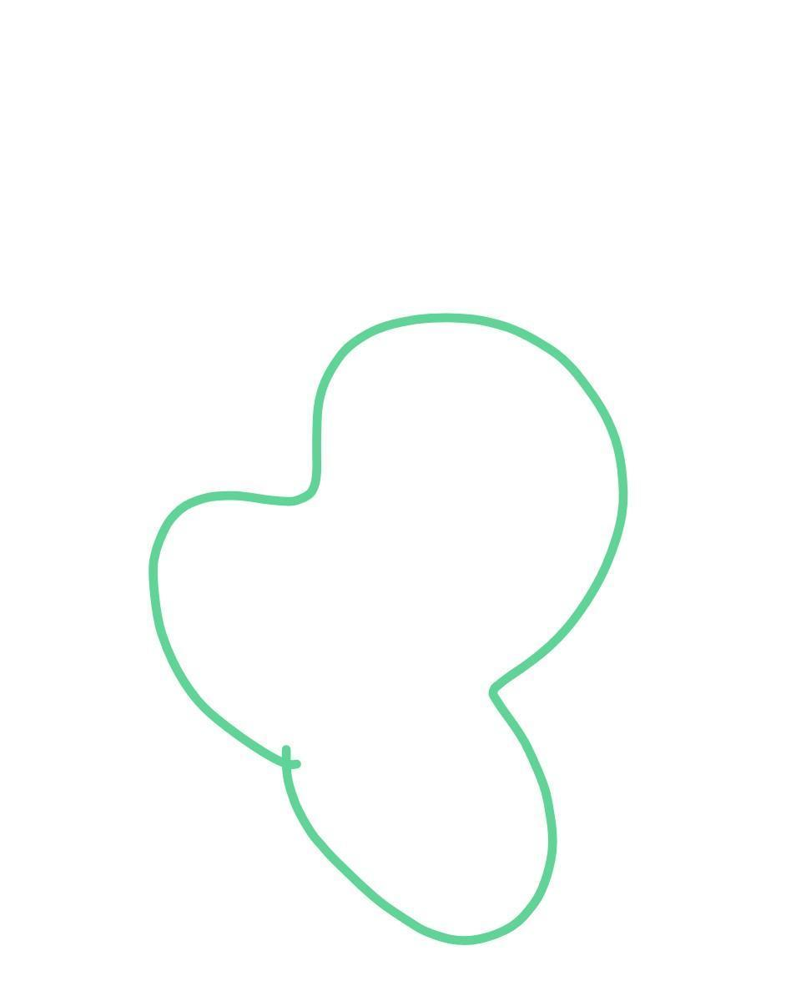
They are common in:
- CAD
- Graphic design
- Illustration
- Product design
- Computer graphics

6. Wavy Closed Curved Shapes
# Source: AI Source: Provided by: [Data Path: Persons Table -> ID Column: 1, Name_En Column: Motasem Essam] -> From: [ChatGPT] on [7/25/2026]
These are closed curves containing irregular or repeated undulations around their boundary.
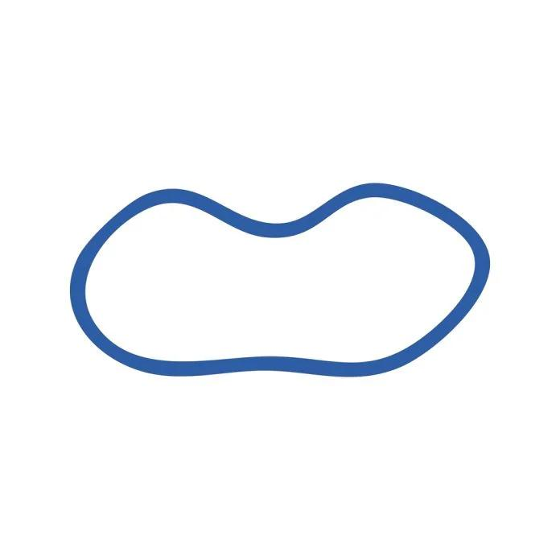
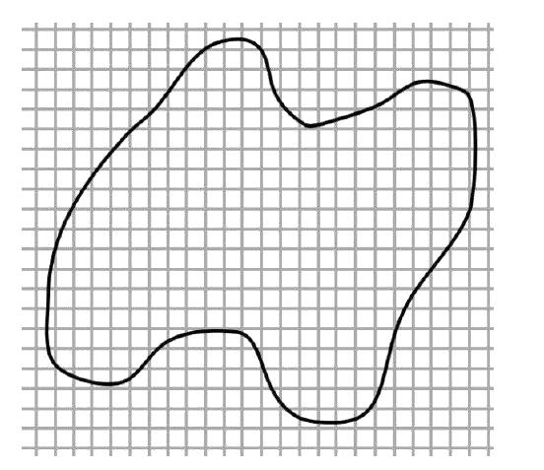
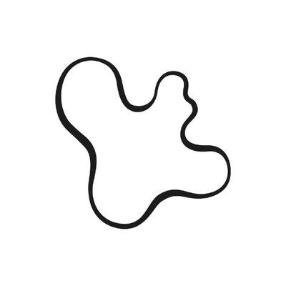
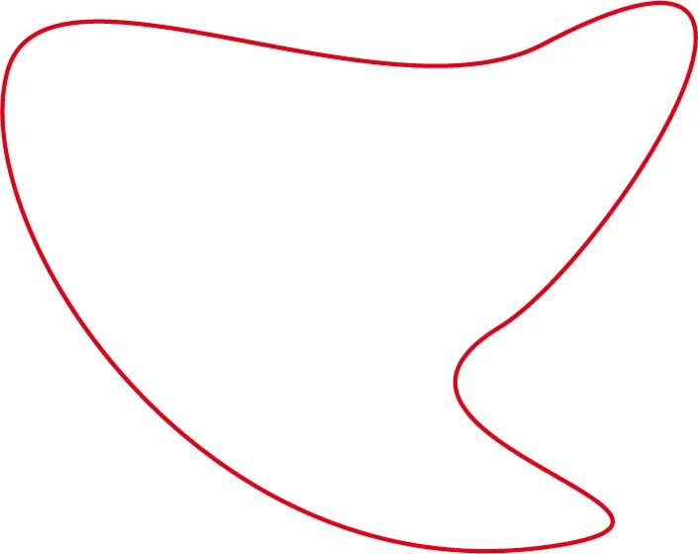
Their boundary may have:
- Repeated waves.
- Unequal amplitudes.
- Unequal spacing.
- Variable curvature.

7. Asymmetric Closed Curved Shapes
# Source: AI Source: Provided by: [Data Path: Persons Table -> ID Column: 1, Name_En Column: Motasem Essam] -> From: [ChatGPT] on [7/25/2026]
These are closed curved shapes that lack regular symmetry.
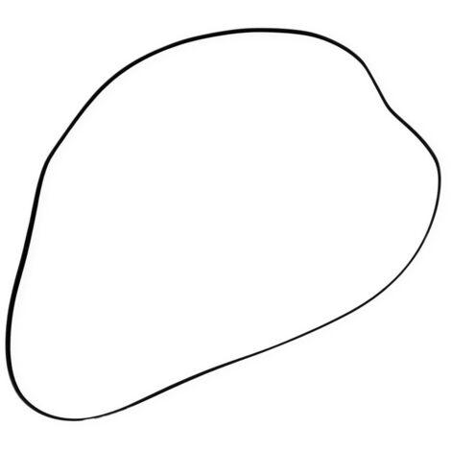
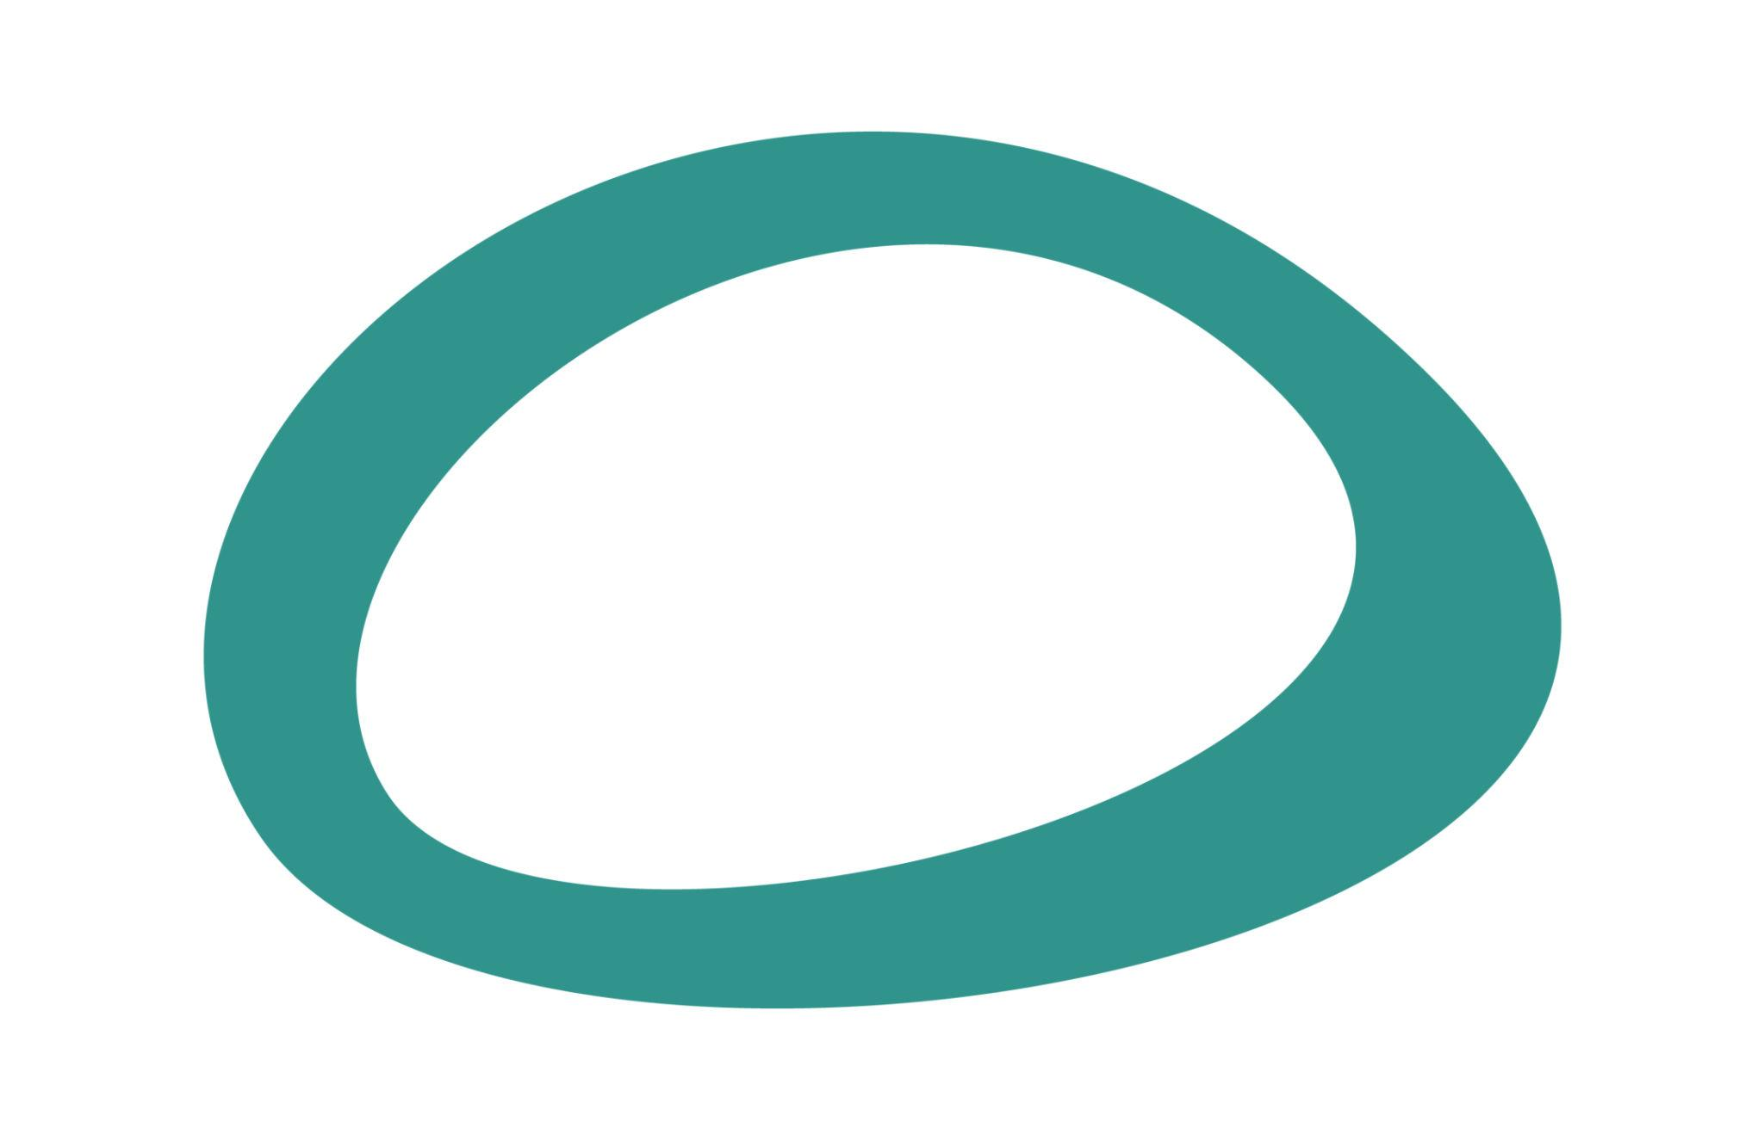
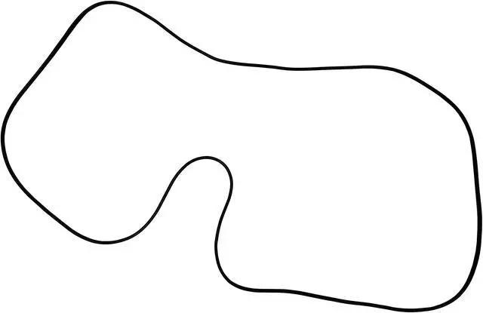
They do not necessarily have:
- Reflection symmetry.
- Rotational symmetry.
- Equal dimensions in different directions.

Classification by Regularity
# Source: AI Source: Provided by: [Data Path: Persons Table -> ID Column: 1, Name_En Column: Motasem Essam] -> From: [ChatGPT] on [7/25/2026]
Closed curved shapes can be divided into:

Regular / Standard Closed Curved Shapes
# Source: AI Source: Provided by: [Data Path: Persons Table -> ID Column: 1, Name_En Column: Motasem Essam] -> From: [ChatGPT] on [7/25/2026]
Examples:
- Circle
- Ellipse
These have well-defined mathematical structures.

Irregular Closed Curved Shapes
# Source: AI Source: Provided by: [Data Path: Persons Table -> ID Column: 1, Name_En Column: Motasem Essam] -> From: [ChatGPT] on [7/25/2026]
Examples:
- Organic closed curves
- Freeform closed curves
- Wavy closed curves
- Asymmetric closed curves
These do not necessarily follow a standard geometric equation.

Boundary
# Source: AI Source: Provided by: [Data Path: Persons Table -> ID Column: 1, Name_En Column: Motasem Essam] -> From: [ChatGPT] on [7/25/2026]
The defining boundary property is:
$$\boxed{P_{\text{start}}=P_{\text{end}}}$$
Unlike an open curve:
$$P_{\text{start}}≠P_{\text{end}}$$
A closed curved boundary separates the plane into an interior and an exterior.
$$\boxed{\text{Interior}+\text{Closed Curved Boundary}+\text{Exterior}}$$

Area
# Source: AI Source: Provided by: [Data Path: Persons Table -> ID Column: 1, Name_En Column: Motasem Essam] -> From: [ChatGPT] on [7/25/2026]
Because a closed curved shape encloses a region, it has an area.
For a circle:
$$\boxed{A=πr^{2}}$$
For an ellipse:
$$\boxed{A=πab}$$
For an arbitrary closed curved shape, the area may need to be calculated using integration, coordinate data, numerical approximation, or image/GIS methods.

Perimeter / Arc Length
# Source: AI Source: Provided by: [Data Path: Persons Table -> ID Column: 1, Name_En Column: Motasem Essam] -> From: [ChatGPT] on [7/25/2026]
The boundary length of a closed curved shape is commonly called its circumference or arc length, depending on the curve.
For a circle:
$$\boxed{C=2πr}$$
For a general parametric closed curve:
$$x=x\left(t\right), y=y\left(t\right)$$
the boundary length is:
$$\boxed{L=\int_{a}^{b}{\sqrt{{\left(\frac{dx}{dt}\right)}^{2}+{\left(\frac{dy}{dt}\right)}^{2}}}dt}$$
with the endpoints satisfying:
$$\left(x\left(a\right),y\left(a\right)\right)=\left(x\left(b\right),y\left(b\right)\right)$$

Closed Curved vs. Closed Polygonal Shapes
# Source: AI Source: Provided by: [Data Path: Persons Table -> ID Column: 1, Name_En Column: Motasem Essam] -> From: [ChatGPT] on [7/25/2026]
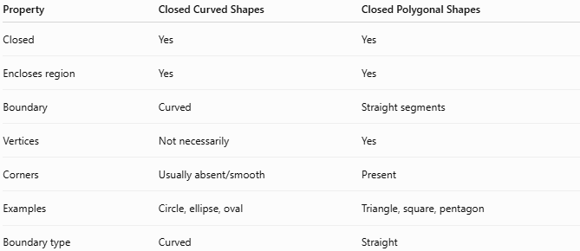
Property | Closed Curved Shapes | Closed Polygonal Shapes
Closed | Yes | Yes
Encloses region | Yes | Yes
Boundary | Curved | Straight segments
Vertices | Not necessarily | Yes
Corners | Usually absent/smooth | Present
Examples | Circle, ellipse, oval | Triangle, square, pentagon
Boundary type | Curved | Straight
The fundamental distinction is:
$$\boxed{\text{Closed Polygonal Shape}→\text{Straight Boundary}}$$
while:
$$\boxed{\text{Closed Curved Shape}→\text{Curved Boundary}}$$

Key Points
# Source: AI Source: Provided by: [Data Path: Persons Table -> ID Column: 1, Name_En Column: Motasem Essam] -> From: [ChatGPT] on [7/25/2026]
A Closed Curved Shape is:
$$\boxed{\text{Closed}+\text{Curved Boundary}+\text{Bounded Interior}}$$
It:
- Has a continuous closed boundary.
- Has no exposed endpoints.
- Contains curved portions.
- Encloses a bounded region.
- Has measurable area.
- Has a measurable boundary length.
- Can be regular or irregular.
- Can be symmetric or asymmetric.
- Includes circles, ellipses, ovals, and many freeform or organic closed curves.

Conclusion
# Source: AI Source: Provided by: [Data Path: Persons Table -> ID Column: 1, Name_En Column: Motasem Essam] -> From: [ChatGPT] on [7/25/2026]
Closed Curved Shapes are closed plane shapes whose boundaries contain curved lines and return to their starting point, thereby enclosing a bounded region. They include circles, ellipses, ovals, organic curves, freeform curves, wavy curves, and asymmetric curves. They can be further classified according to their mathematical form, regularity, symmetry, and curvature, making them a distinct category from Closed Polygonal Shapes, whose boundaries consist entirely of straight line segments.

